Battery Box 2013 Improvements

# Surface Mount

All components should be replaced with their surface mount equivalent. For the resistors and capacitors the size of the devices should be 0805 to make hand soldering of test boards possible.

Some components will not be able to be switched to surface mount be switching as many as possible will bring down production costs and they will be able to be machine soldered.

# USB Changes

Firstly the USB power should have current limiting on. This will prevent damage to phones which try to pull more than 500mA. It will also stop the audible ringing when this situation occurs. To implement this we can use a device such as [this](http://onecall.farnell.com/diodes-inc/ap1212lsg-13/ic-switch-usb-low-8sop/dp/1825303).

Secondly a voltage bias should be added to the USB data lines, this will make our charging ports compatible with more devices. The following website have looked into the correct biasing in detail and found these values to be the most compatible.

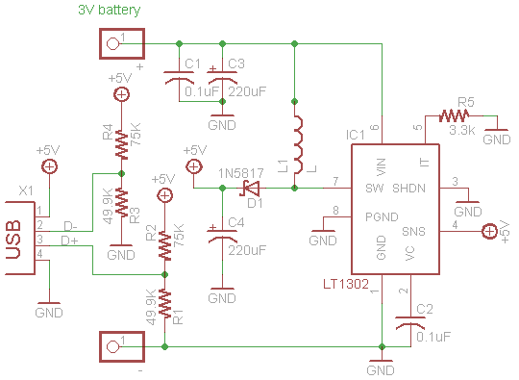

# Connector Mountings

Rather than connecting the mounting through terminal blocks and wires we should be mounting them straight onto the PCB and mounting the PCB directly behind the faceplate. For this we will carry on using the vertical mount USB sockets ([here](http://onecall.farnell.com/lumberg/2410-01/usb-type-a-receptacle-panel/dp/1177882?Ntt=117-7882)) but will have to switch from panel mount to vertical PCB mount DC jacks. [These jacks look suitable](http://uk.mouser.com/ProductDetail/Kycon/KLDVX-0202-B/?qs=sGAEpiMZZMvEZpvz4iUm3q0Yvn/b8os7).

We will also need to investigate how to mount the PCBs securely to the faceplate. The only connect made off the PCB will be to the power switch and battery. However if we could also mount the power switch on the PCB also then this would be beneficial but this seems very difficult. The battery and switch should be connected using something like [this](http://onecall.farnell.com/molex/26-03-4020/housing-3-96mm-2way/dp/1756831?crosssellid=1756831&crosssell=true&in_merch=true&) which should be easier, more reliable and cheaper than the terminal blocks.

# Protection Circuit

Currently we have a PTC and fuse. These do not protect the Mosfet during over-current (output shorted to ground) situations as they do not act fast enough. Many boxes are failing due to this. We need to add faster acting input protection, possible a current sense resistor with the voltage drop connected to the analogue comparator of the PIC, this can be linked to an interrupt to disable the output and indicate the user of the error. This may still not be fast enough, so could also add a more resilient Mosfet.

Reverse battery protection could also be added if this is found to cause damage to the electrosnic.

# Charging Indication

We should provide some visual indication id charging. This can simply be done by flashing the bi-colour LED during charging.

# Optional Data-logging Unit

We would like a way to optional add data-logging systems to these boxes. This would profile how they are being used over time. We would not add these to all boxes due to cost but it would be nice to have the option to add this to some boxes. We could either design all PCBs to be able to do this but only solder the required data-logging components to selected boxes or add in a second data-logging PCB which monitors usage. We would have to think carefully about how we would retrieve the data from these boxes.